Design for Emotion and Flow By Trevor van Gorp

Software and websites are created to present information to users. The information might identify a company’s products, display pictures of your aunt’s vacation, or help you meet a potential mate. As a citizen of the modern age, there’s more information available to you than at any other time in history.

An abundance of information has many positive effects but it also creates problems. As Nobel laureate Herbert Simon once stated, “what information consumes is rather obvious; it consumes the attention of its recipients... a wealth of information creates a poverty of attention.” (Simon 1971)
When attention becomes a scarce resource, information architects, interaction designers and visual designers all play a role in ensuring the products they design receive users’ investments of attention.

The psychologist Mihaly Csikszentmihalyi (1990) has described focused attention as psychic energy. Like energy in the traditional sense, no work can be done without it and through work that energy is consumed.
Most of us have experienced a mental/emotional state where all our attention or energy is totally focused on an activity. Csikszentmihalyi (1990) named this state “flow”, based on how study participants described the experience. Norman (1998) has also described this state as “a continual flow of focused concentration" and named the experience “motivated activity”.
While in this state, we may experience feelings of intense concentration and enjoyment coupled with peak performance. Hours may pass by in what seems like minutes.
We tend to enter these states in environments with few interruptions, where our attention becomes focused by a challenge that we’re confident we can handle with our existing skills. As we address the challenge, feedback is instantaneous, so we can always judge how close we are to accomplishing our task and reaching our goal. The importance of a task influences the users’ level of motivation and the perception of how challenging the task will be.

Attention and Flow

Since Csikszentmihalyi’s (1977) initial research on flow, a number of elements have come to be associated with the experience. These various elements have been further classified into the causes, characteristics and consequences of flow. (Novak, Hoffman and Yung, 1999)

Causes of Flow
- A clear goal
- Immediate feedback on the success of attempts to reach that goal
- A challenge that you have the skills to handle.

Characteristics of Flow
- Total concentration and focused attention
- A sense of control over interactions
- Openness to new things
- Increased exploratory behavior
- Increased learning
- Positive feelings

Consequences of Flow
- Loss of consciousness of self
- Distortions in the perception of time
- Activity itself is perceived as intrinsically rewarding

Of these three areas, as designers, we want to focus on the causes, or elements that precede flow. Users come to your site with pre-existing goals (e.g. finding information about a product) but those goals will evolve as they complete tasks, and their attention is drawn to other items.
As designers, the main elements we can control involve:
- Providing immediate feedback
- Balancing the perception of challenge against users’ skills.

Designing for Flow

So how do we design for flow? You’ll be happy to know that you probably already are. And you don’t need to learn a new set of tools either. Just apply your existing tools with the creation of flow as a desirable outcome.

Start by reducing distractions and impediments wherever possible. For both physical and interactive products, this means reducing or eliminating both external (i.e., environmental) and internal (i.e., pain, discomfort, anxiety) distractions that cause emotional responses like frustration or discomfort and divert users’ attention. Providing immediate feedback for all user actions helps to reduce user anxiety. Effective layout, information design, typography, interaction design and information architecture help to balance the perception of challenge against the user’s skill level. In well-designed interfaces, information and tasks are broken down into manageable “chunks” that don’t cognitively overwhelm users.

When it comes to balancing the perception of challenge, think of it this way; too much challenge with too little skill causes anxiety. Too little challenge with too much skill causes boredom. Flow can occur when the anxiety level is balanced. Csikszentmihalyi illustrated the concept as a channel that runs between anxiety and boredom. (Figure 1)

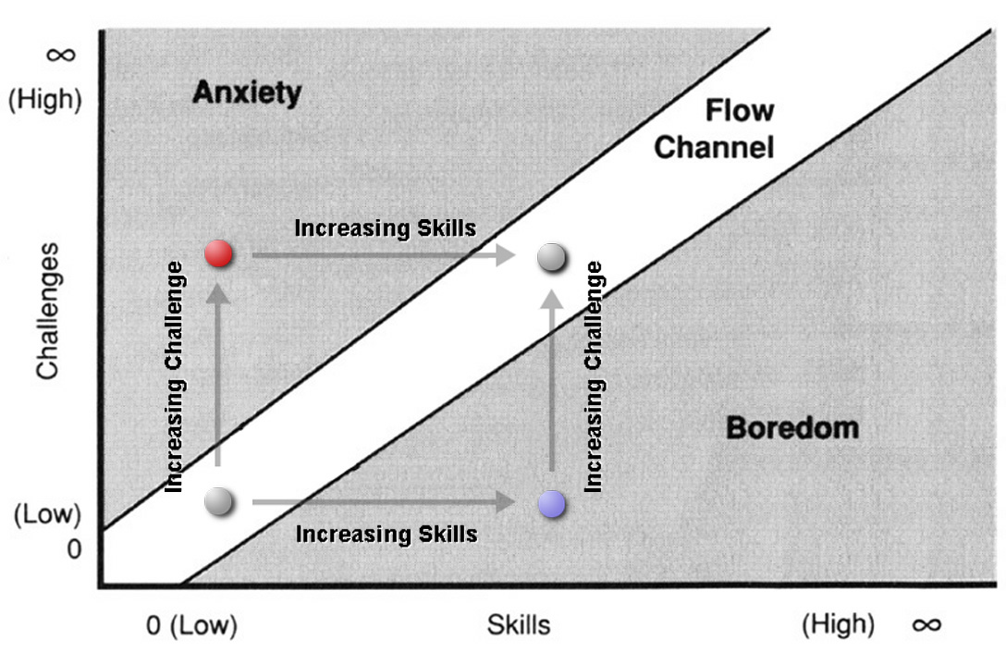
Figure 1: Anxiety, Boredom and Flow (Csikszentmihalyi 1990)
(captions on arrows added by van Gorp, 2006)

Flow occurs at the boundary between boredom and anxiety. As we increase the challenges we face, we become more anxious. Re-entering flow involves increasing our skills to match these challenges. As we increase our skills, we become bored. Re-entering flow involves increasing the challenge to match our increased skills.

To understand how we can reduce distractions, let’s examine the different elements of flow again and see how each can be applied to user experience. The causes of flow have the most implications for website and application design.

Causes of Flow
1. A clear goal...
The user navigates to accomplish a task, like seeking information on a particular topic, or surfing for fun. This is an evolving goal; dependent on the options the user is presented and aided by effective information architecture, indicators of the users’ location, and clear options for proceeding (in the form of information scent, breadcrumbs, effective page titles, button/link selected states, visited links, buttons etc.)

2. With immediate feedback on the success of attempts to reach that goal...
The user receives a quick, sensory response in the form of a visual shift and/or sound from links, buttons, menus and other navigation items.

3. Presented as a challenge that you have the skills to handle
The opportunities for action are balanced with the user’s ability. At a basic level, this is accomplished by providing an uncluttered interface and eliminating unnecessary information to reduce the cognitive load on the users’ attention. But as the users’ skill increases over time, the interface needs to be able to evolve with the user. This could be accomplished through adaptive interface technologies that allow the user to adjust the complexity of the interface to match their skill level.

Flow and Emotion

Flow tends to occur in situations with higher levels of challenge and skill. If there is too little challenge, or skill levels are too high, there is low anxiety and we often lack the motivation to do anything. Researchers call this the level of activation or arousal in the body. Arousal is the physiological (i.e. bodily) dimension of emotion and it’s important for discussing flow because things that increase arousal tend to demand our attention.

If you think of it in evolutionary terms, it’s easy to see why; the more attention our ancestors paid to predators, the more likely they were to survive and reproduce, passing their genes on to you and me. Both pleasant and unpleasant objects and experiences can create increases in arousal. This can include everything from frustrating errors, to interfaces that praise the user for successfully completing tasks (Fogg 2003), to large images, bright colors and high contrast. (van Gorp, 2006) For example, increasing the size of an image, and moving anyone in it closer in the frame both can increase arousal.


Interpersonal Distance and Arousal
How does looking at the picture on the right make you feel compared to the one on the left?

The key is balancing arousal by matching the perceived challenge to the users’ skills. But the level of skill differs from one user to the next based on the type of task and their experience. As Csikszenmihalyi put it, “the key attribute is that it should be very user friendly and transparent at first, but one should immediately be able to find the right level of challenges for “action” that match one’s skills. These “challenges” include the visual aspects as well as the content.” (King 2003) To put it even more simply, everything about a site including the content, information architecture, interaction design and visual design can contribute to flow.

Goal-directed vs. Experiential Use
Researchers have found that different kinds of site usage require different site designs to facilitate flow. (Novak, Hoffman and Yung 1996) Novice users tended to see the Internet in a playful way, while more experienced users view the Internet in a utilitarian way. (King 2003) This leads to a distinction between experiential and goal-directed Internet use. Due to the higher challenge involved, flow was recorded more often in goal-directed use.
Novice Users - Experiential use
- Less challenging
- More exploratory
- Entertainment-oriented

Experienced Users - tendency towards Goal-directed use
- More challenging
- Less exploaratory
- Connected with tasks (e.g. research, work and shopping)

The lower level of challenge in an entertainment-oriented, experiential site means there is a lower level of anxiety connected with its use. Someone who is less anxious is more capable of using creative thought to figure out how to navigate a website and overlook minor problems. Motivation here is due to unconscious arousal created by interesting visual elements like bright colors or high contrast. This means that experiential sites can and should be more arousing visually to elicit the greater attention that can lead to flow experiences.
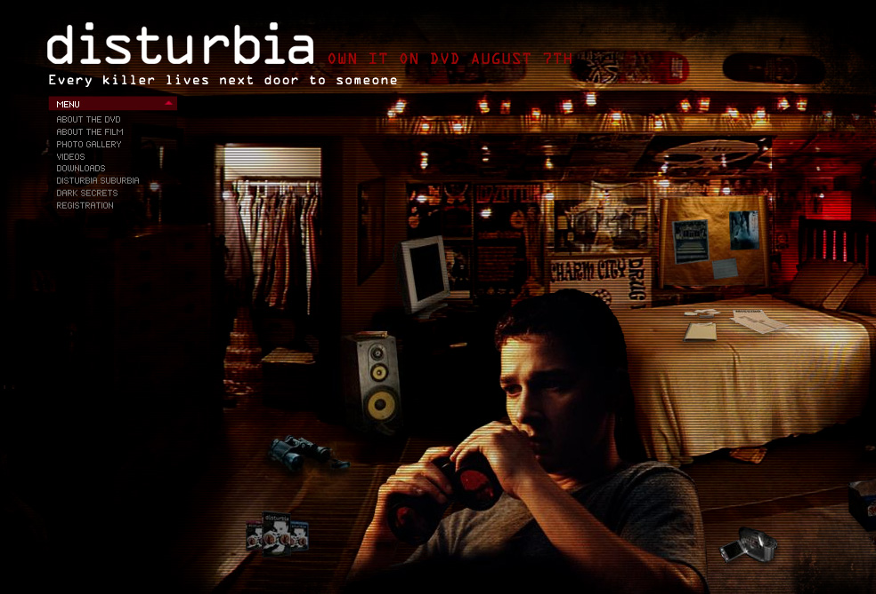
Disturbia film site
http://www.distubia.com
An example of an entertainment oriented site
The greater challenge of completing a task on a goal-directed site creates more challenge and arousal, independent of the site’s design. Someone who is more anxious is much less likely to be able to come up with creative solutions to any problems that are encountered. So when a site or product will be used in a stressful environment, like a hospital operating room, usability is especially important. All relevant information needs to be close at hand and visible. Feedback should always be clear and immediate. A goal-directed site should be less visually rich so that users, already anxious at the prospect of a challenging task, are not overwhelmed.
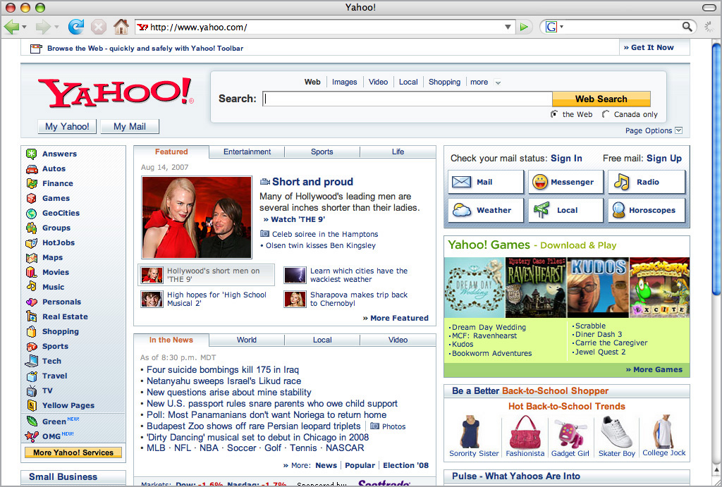

Yahoo
http://www.yahoo.com
The implications of this idea for websites and applications is that those designed for fun and entertainment can get away with having less usable interfaces. Sites or applications that are used in stressful or dangerous situations require more attention to usability, since the user’s capacity to process information will be reduced. (Norman 2004)
Many tasks are boring or unpleasant. In those cases, increasing the arousal level can increase the user’s motivation. Narrative is also a useful element to help increase motivation. The Tango Tax website uses visual elements that resemble those found in movie posters and has a cinematic feel to increase arousal. The Tango Tax software also introduces the narrative element of “us vs. them” to help increase user motivation.
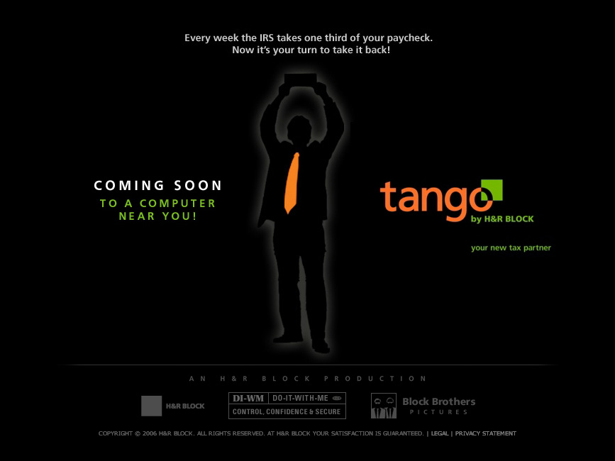
Tango Tax
http://www.tangotax.com

Conclusions - Traits of Websites that Encourage Flow
The application of these ideas depends on your target user group and their internal and external context of use. Knowing your user has become more important than ever before. Here are some basic website traits that will help to encourage flow.

Clear navigation:
Make it easy for the user to know where they are, where they can go, and where they’ve been by including signposts like breadcrumbs, effective page titles, and visited links.

Immediate Feedback:
Make sure all navigation, like links, buttons and menus provides quick and effective feedback. Make sure user actions always receive feedback. When you can’t manage this, provide an indicator to hold the user’s attention while they wait. (e.g. progress bar)

Balance the Perception of Challenge With the User’s Skill:
Since all users’ skill levels will differ, its up to you to balance the visual design of the site with the tasks the users need to accomplish. Consider whether they are likely surfing experientially for fun or to complete an important task. Tailor your sites to your target audiences.

Adaptable interfaces that allow the user to choose how much information is displayed evolve with use by increasing or decreasing the perceived challenge. Simplicity helps reduce anxiety for novices and those in highly stressful situations. An option for more detailed or information rich displays can introduce challenge for more experienced users.

Remember, designing for flow doesn’t require a new set of tools or skills - only a different way of thinking. Balanced emotions and focused attention can create flow, which results in engaging and immersive user experiences.

- Si

mon (1996) noted that the creators of information systems designed those systems to provide more information to people, when instead they should have designed systems that optimized attention and reduced distractions by displaying only the most relevant information.
Whether you’re an information architect, interaction designer, or visual designer, your work should be convincing users to invest their attention and providing them with a return on their experience. Managing the perception of challenge to foster flow can be an effective way to provide compelling user experiences.

References
Csikszentmihalyi, Mihaly. (1990). Flow - the Psychology of Optimal Experience. New York: Harper Perennial.

Csikszentmihalyi, M. (1977). Beyond Boredom and Anxiety, San Francisco: Jossey-Bass. Copyrights: Journal of E-Business (International Academy of E-Business). All rights reserved. Journal of E-Business, Vol. 1, Issue 2, December 2001.

King, Andrew B. ”Chapter 2 – Flow in Web Design.” 2003. http://www.websiteoptimization.com/speed/2/ accessed on January 21/2007.

Fogg, B.J. (2003). Persuasive Technology - Using Computers to Change What We Think and Do. San Francisco: Morgan Kaufmann Publishers.

Hoffman, D.L, Novak, T (1996), "Marketing in hypermedia computer-mediated environments: conceptual foundations’", Journal of Marketing, Vol. 60 pp.50-68.

Norman, Donald A. (2004). Emotional Design - Why We Love (or Hate) Everyday Things. New York: Basic Books.

Novak, T.P, Hoffman, D.L (1997), "Measuring the flow experience among Web users", Interval Research Corporation, http://www2000.ogsm.vanderbilt.edu/, .

Novak, T, Hoffman, D, Young, Y (1998), "Measuring the flow construct in online environments: a structural modeling approach", Owen Graduate School of Management, Vanderbilt University, working paper, http://www2000.ogsm.vanderbilt.edu/papers/flow. construct/measuring_flow_construct.html,

Novak, T. P., Hoffman, D. L., and Yung, Y. 2000. Measuring the Customer Experience in Online Environments: A Structural Modeling Approach. Marketing Science 19, 1 (Jan. 2000), 22-42. DOI= http://dx.doi.org/10.1287/mksc.19.1.22.15184

Rettie, R., (2001), An Exploration of Flow during Internet Use, Internet Research, 11(2), 103 – 113.

Simon, H. A. (1971), "Designing Organizations for an Information-Rich World", in Martin Greenberger, Computers, Communication, and the Public Interest, Baltimore, MD: The Johns Hopkins Press, ISBN 0-8018-1135-X. p. 40-41.

Simon, H. A. (1996), The Sciences of the Artificial (3rd ed.), Cambridge, MA: The MIT Press, ISBN 0-262-69191-4. p. 143-144.

van Gorp, Trevor, J. (2006). Emotion, Arousal, Attention and Flow: Chaining Emotional States to Improve Human-Computer Interaction. University of Calgary, Faculty of Environmental Design, MDP.

As a reader that has no formal education in design and little knowledge of interfaces I found it very easy to understand. The material is well laid out and you give solutions to all of the problems that you introduced. I was previously an English minor and that editing nazi comes out sometimes when I am reading, but most of it I am sure you will take with a grain of salt. I feel like I now understand how to design for flow and I have never designed anything before.

